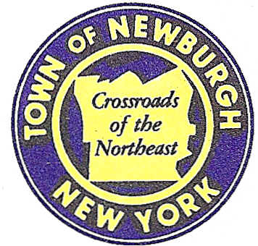

TOWN OF NEWBURGH
_______Crossroads of the Northeast __________________________
OLD TOWN HALL
308 GARDNERTOWN ROAD NEWBURGH, NEW YORK 12550

PLANNING BOARD
JOHN P. EWASUTYN, CHAIRMAN TELEPHONE 845-564-7804
FAX 845-564-7802
E-MAIL: planningboard@townofnewburgh.org

PLANNING BOARD AGENDA

AUGUST 21, 2014

**PLEASE NOTE: The Planning Board Meeting will start at 7:00 P.M. and all Applicants/Representatives
are to be present at that time. The Meeting will be held in the Meeting Room of Town Hall, located at
1496 Route 300, Newburgh NY.**

- Britain Plaza (2013-13)  169 Old Little Britain Road  Section 97, Block 3, Lots 1& 2  Zone: IB  Rep: Lanc & Tully, PC  P.O. Box 687  Goshen, NY 10924 | SITE PLAN
- Pond View 2 Lot Subdivision (2014-19)  921-965 State Route 32  Sec. 10, Blk. 1, Lot 50  Zone: RR  Rep: Hudson Land Design  174 Main Street  Beacon, NY 12508 | INITIAL APPEARANCE  SITE PLAN
- Magyar Budget Truck Rental (2011-04)  5465 Route 9W  Sec. 9; Blk. 1; Lots 3 & 6  Zone: B  Rep: Frank Valdina, PE  Valdina Consulting Engineers  4 Pleasant View Avenue  Newburgh, NY 12550 | SITE PLAN
*WORK SESSION: Project Readiness Discussion scheduled for 5:30 p.m. in the Meeting Room
of Town Hall on Thursday, August 21, 2014*

PLANNING BOARD BUSINESS
WORK SESSION

AUGUST 21, 2014

Discussion:

- Verizon (2014-13):
Discussion of final approval.

- Golden Vista (1999-33):
The Applicant is requesting a 90 day conditional final site plan approval extension from
29 September 2014 to 27 December 2014.

- Lands of Zazon (2004-29):
The Applicant is requesting a six month conditional final approval extension from
19 September 2014 to 19 March 2015.

- Trinity Square (2006-53):
The Applicant is requesting a six month conditional final approval extension from
21 August 2014 to 21 February 2015.

